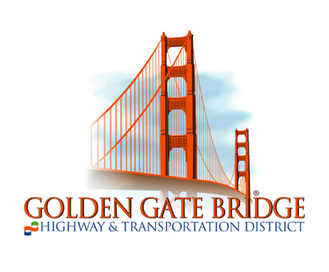
Ferry Passengers Advisory Committee

(FPAC)

Minutes of Meeting of Monday, November 8, 2021

FPAC Members Present: Chuck Hornbrook, Erik Selvig, Michael Stryker, Jamie Taylor, Bardha Varfaj, Adam Wright

Guests Present: Liz Judge, Public Comment; Jim Mastin, Board of Directors; Dominic Moreno, Port of San Francisco

Staff Present: Collette Martinez, Manager of Ferry Operations; Josh Widmann, Planning Department

Approval of Summary of Meeting of July 26, 2021. Minutes were approved.

- Operational Issues
- Ridership Updates. Josh Widmann reported that Ferry ridership is approximately 1,000 trips per weekday and 2,000 – 3,000 on weekends per day, depending on the weather and special events. Pre-COVID ridership was approximately 8,000 per weekday. A third Larkspur commute southbound trip was added in September.

- Service Updates. Angel Island service planning efforts continue, with over a dozen comments received for the November 5 public hearing. Weekdays will be five round trips and weekends will be four round trips. Group fares will possibly be considered at some point in the future. Collette Martinez gave an overview of how the Sausalito and Angel Island trips will be operated by the same vessel crew. Chuck Hornbrook stated there is a reluctance among Tiburon riders to utilize service currently due to the Sausalito triangle stopover. Ms. Martinez also provided Chase Center basketball service updates, indicating that in 2019-2020 we only averaged 70 riders per trip, so future service would be dependent on an increase in demand, as special event service is required to break even.
- Updates and Other Items
- Vessel Updates. The M.V. Mendocino is still in San Diego; however, it will be returning for sea trials in the coming days and placed into service in the following week. After the M.V. Mendocino returns, the M.V. Golden Gate will go out for servicing. The M.V. Del Norte will also be going out for servicing to Bay Ship and Yacht, locally, and will return mid-September 2022. Angel Island service will be provided by Spaulding vessels.

- Terminal Updates. Gate B in San Francisco will be used for the foreseeable future. All WETA service has been shifted to Gates E, F, G, and H. Sausalito landside improvements are moving forward in the design stage, to accommodate a larger bicycle queue.

- Return to Office Timeline Discussion. Ms. Varfaj updated the group on her office’s return to work plan with a new estimate of January or February for part time office workers at the California Street location. Jamie Taylor stated he had heard of January 18 as the return date for Google, with an initial plan of two days per week commuting. Michael Stryker stated UCSF workers in Mission Bay can easily park on the street currently, but when it becomes more difficult they may start using transit again for two to three days per week.

3. Committee Business
A. FPAC Initiatives.
i. Larkspur 42 Crossings/Parking Needs Environmental Review. Mr. Widmann reported that the regional travel demand model from MTC has been delayed due to the difficulty of establishing a new baseline in the COVID and post-COVID era. The overflow parking location has been identified as a possible first stage of garage construction and the consultants are evaluating the details. The estimate for a community kickoff meeting is now Spring 2022. Michael Stryker stated the overflow location would not be ideal due to the longer walk time to the terminal area. Jamie Taylor noted that the main lot takes 25 minutes to empty out in the afternoon so an overflow location might allow commuters to more easily exit the lot. Ms. Martinez stated the overflow location is not on bay mud like the main lot, and would be easier to construct.

ii. Sonoma-Marin Bike Share. Parking corral space will be for 15 bikeshare bicycles, in the former news rack area. A coordination agreement has been signed by all participating agencies in the two-county area; however, the revokable license agreement for occupancy at the Larkspur Ferry Terminal is still under legal review.

- Membership Recruitment & New Member Vote. Mr. Widmann reminded the committee that FPAC now stands at eight members with a large list of prospective members from previous outreach efforts.

- Member/Visitor Comments
Visitor Liz Judge discussed the Tiburon schedules and triangle service with Sausalito, stating the extra travel time due to the Sausalito stopover has resulted in lower Tiburon ridership, however direct Tiburon commute service could increase ridership.

- Next Meeting: January 10, 2022.
The committee agreed to reconvene on January 10, 2022 from 12:00 p.m. to 1:00 p.m. using the Zoom meeting format.

