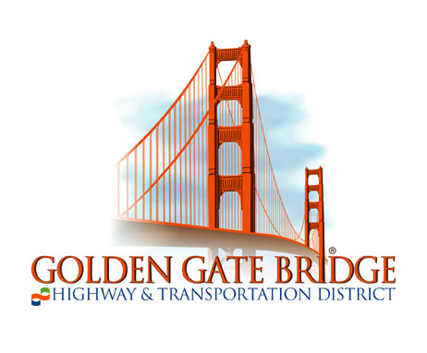
Ferry Passengers Advisory Committee

(FPAC)

Minutes of Meeting of Monday, June 13, 2022

FPAC Members Present: Jordan Jaffe, Maryline Lewett, Erik Selvig, Michael Stryker, Bardha Varfaj, Adam Wright,

Guests Present: Bert Hill, Board of Directors; John Looper, Guest; Jim Mastin, Board of Directors

Staff Present: Collette Martinez, Manager of Ferry Operations; Carlena Natouf, Supervisor of Customer Relations; Josh Widmann, Planning Department; Glenn Williams, Director of Ferry Operations

- Approval of Summary of Meeting of April 11, 2022. Minutes were approved.

- Operational Issues
- Ridership Updates. Josh Widmann reported recent June ridership. Some weekend days are surpassing 5,000 unlinked passenger trips due to baseball ridership. Recent weekday ridership averages around 3,000 per day, depending on the weather. The 5:25 p.m. Larkspur northbound weekday trip, the most utilized commute trip, carried 324 passengers on a recent trip. Total daily Larkspur ridership is around 1,700, while pre-COVID it was around 6,500. Tiburon is averaging around 350 daily one-way passenger trips, while pre-COVID it was approximately 850 per day.

- Service Updates. Mr. Widmann noted the existing 54-trip daily weekday ferry schedule. Upcoming changes will go into effect June 27. Collette Martinez explained the reasoning behind some upcoming schedule changes due to the limitations of Gate B. Ms. Martinez also noted that the baseball ridership has been exceeding expectations. The Muir Woods shuttle use of the Larkspur Ferry Terminal parking lot has resulted in approximately 400 daily riders, with an anticipated increase to 1,000 by July. Service is weekends only currently.
- Updates and Other Items
- Vessel Updates. Ms. Martinez reported that the M.V. Napa and M.S. Marin are in San Diego, while the M.V. Napa is only approximately a week away from returning to the active fleet. When these vessels return, the M.S. San Francisco will go out for its two-year servicing. The new build vessel contract for the design phase of the project will be awarded soon. The committee discussed clean engine technology opportunities for existing vessels and future vessel purchases.

- Terminal Updates. The group discussed the possibility of a coffee cart inside the Larkspur Ferry Terminal paid waiting area, as the onboard vendor service has not yet resumed. Some tailgating at Larkspur Ferry Terminal parking lot was noted, and it will be addressed soon. The Larkspur channel dredging project will occur throughout the summer and will be finished by September. Glenn Williams, Director of Terminal Operations was introduced at this juncture in the meeting.

- Return to Office Timeline Discussion. Bardha Varfaj updated the group, noting that Wells Fargo has started a three-day-per-week return to the office. Some companies are not requiring a return to the office at high frequencies due to the start of the summer vacation for children. Eric Selvig shared that at his office, the Wednesday on-site worker numbers have dropped, and on Mondays and Fridays, just single digits are working onsite. Michael Stryker stated that at UCSF no comprehensive announcements have been made, however, Tuesday through Thursday are the popular onsite days. Mr. Stryker noted that parking is still relatively easy at UCSF in Mission Bay, so employees are driving in to the office as opposed to taking transit.

- Muir Woods Ferry Shuttle Updates. The Muir Woods bus shuttle will be stopping at the Larkspur Ferry Terminal parking lot on weekends to make the connection for SMART and ferry riders. Select weekday service will begin later in the summer season.

- Committee Business
A. FPAC Initiatives.
i. Larkspur 42 Crossings/Parking Needs Environmental Review. The baseline calibrations continue for ridership projections. District staff are working with the MTC to discuss details of North Bay travel for the 2019 baseline.

ii. Sonoma-Marin Bike Share. Bolt bike share batteries have yet to arrive. A designated area near the picnic tables is still reserved for eventual bicycle corral parking area. Details on the City of Richmond bike share, also operated by Bolt, can be found at: https://ridegotcha.com/locations/richmond.

iii. E.V. Charger Update. The electric vehicle charger upgrade project was not included in the FY22-23 budget, unfortunately. There were higher priority items from the Ferry Division, including inner berth repairs in San Francisco, Larkspur channel dredging, fuel farm rehabilitation, and a subterranean water main replacement project.

iv. Electric Vessel Discussion. Michael Hoffman will be part of a delegation put together by the Norwegian Consulate General’s office on innovation. Mr. Hoffman will provide updates when he returns.

- Membership Recruitment & New Member Vote. No membership recruitment is underway due to the current sufficient FPAC size and existing prospective member waiting list.

- Member/Visitor Comments
The committee discussed the possibility of an interim meeting to discuss clean energy vessel updates, led by Michael Hoffman.

- Next Meeting: August 8, 2022.
The committee agreed to reconvene on August 8, 2022 from 12:00 p.m. to 1:00 p.m. using the Zoom meeting format. This meeting time was later modified to 12:15 p.m. to 1:15 p.m.

